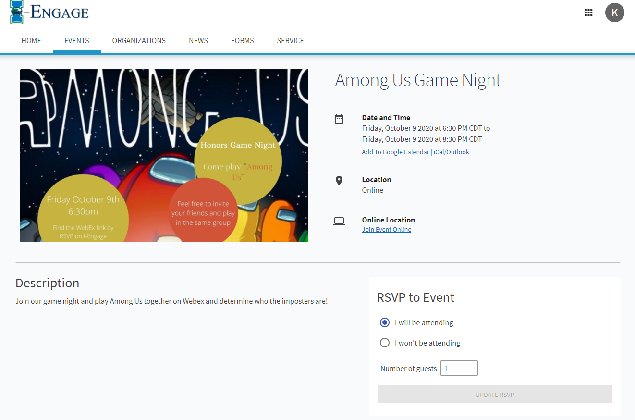

I will be going to the Amon Us game night tonight, I have been to one of the other game nights and they are very fun, I will invite some of my friends from Round Rock to join us and we can play among us for a little bit. This is a fun way to stay engaged and be able to interact with other students. This is the closest I’ve felt like to being included and in a club since COVID-19 started.